Game Design Document

Fill up the Following document

1. Write the title of your project.

Ans. Bubble Shooter.

1. What is the goal of the game?

Ans. Scoring high gold coins.

1. Write a brief story of your game?

There are colourful many balls in my game. There is a shooter to

shoot the balls. There are 5 different levels in my game.

At every level this game becomes more difficult. At every level the

gold coins will increase. Here, the shooter has to shoot 3 or more

balls of same colour.

1. Which are the playing characters of this game?

* Playing characters are the ones which respond to the user based on the input from the user
* Cars, monkeys, dinos, wizards etc, are the playing characters in the game.

|  |  |  |
| --- | --- | --- |
| Number | Character Name | What can this character do? |
| 1 | Shooter | Shoot the balls |
| 2 | Balls | Balls disappear when shooter shoot 3 or more balls of the same colour continuously. |
| 3 |  |  |
| 4 |  |  |
| 5 |  |  |
| 6 |  |  |
| 7 |  |  |
| 8 |  |  |

1. Which are the Non Playing Characters of this game?

* Non Playing characters are the ones which don't have an action or a behaviour when the user interacts with the game.
* Hurdles, stones, bananas, coins, etc are non playing characters in the game.

|  |  |  |
| --- | --- | --- |
| Number | Character Name | What can this character do? |
| 1 | Bubbles | They are Static |
| 2 | Gold coins | They are Static |
| 3 |  |  |
| 4 |  |  |
| 5 |  |  |
| 6 |  |  |
| 7 |  |  |
| 8 |  |  |

Draw your imagination of this game. What does this game look like?

* Draw the game either on your computer or on paper,
* Add images of scenes of the game to show each of the playing and non-playing characters at least once.

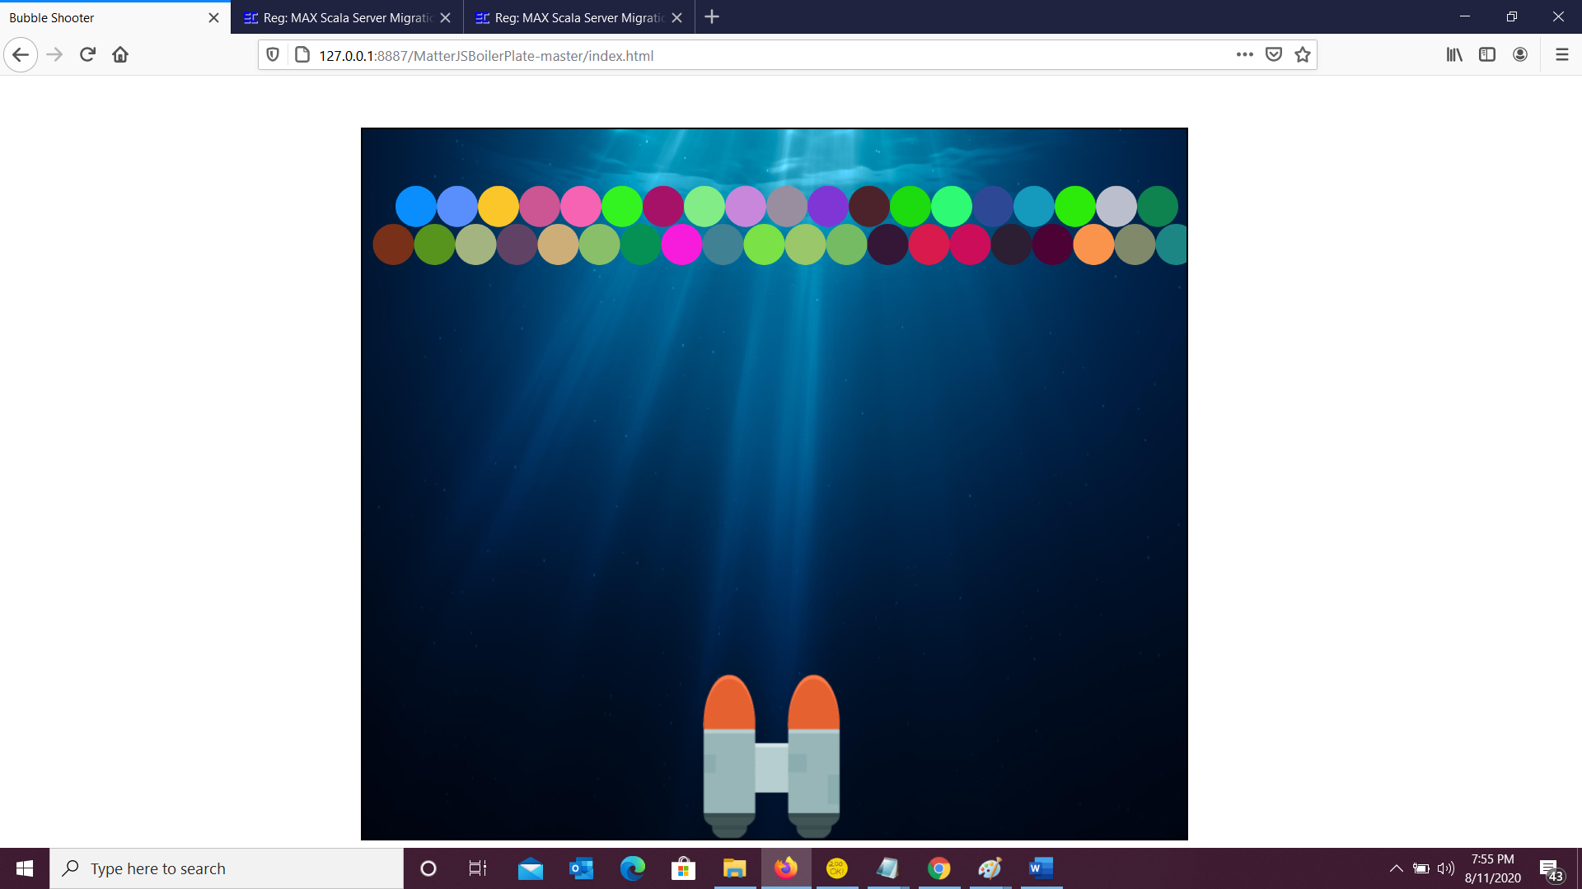

How do you plan to make your game engaging?

Ans. As the player moves to the next level my game becomes more and more interesting.